**One Sample Z-Test**

**With Numbers (data)**

Click “Stats” and under “Z-Statistics” Select “One-Sample” and then “With Data”

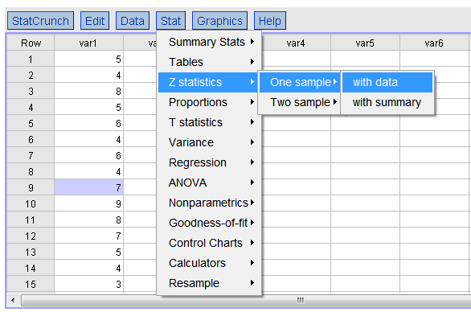

You will get this window.

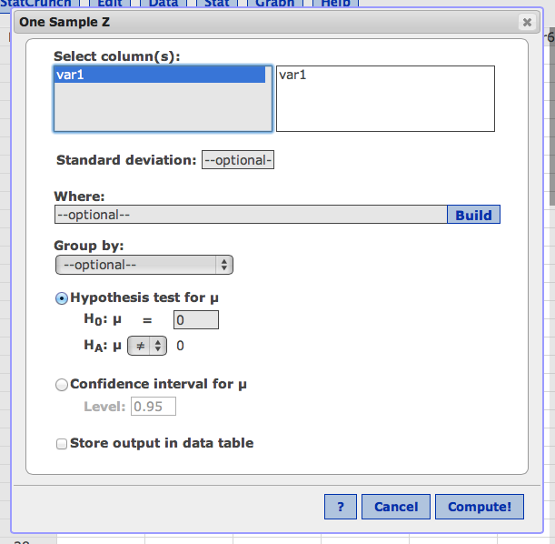

Click on the variable to move it over.

In Standard deviation: enter your population sigma (standard deviation, given to you in the problem). You MUST enter this to get sigma m (om) and the rest of the numbers you need for the steps.

Under hypothesis test for u (mu), enter u = population mean (given to you in the problem). You MUST change this one to get the right z-score.

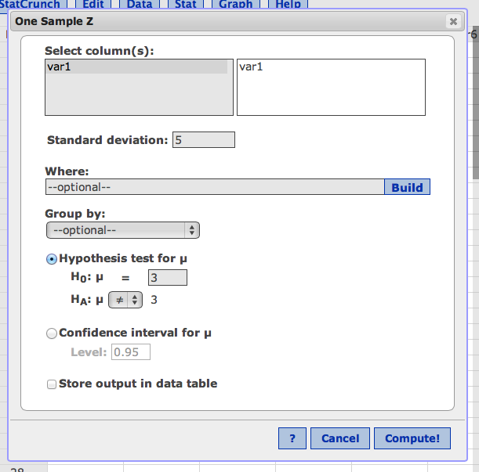

Hit compute.

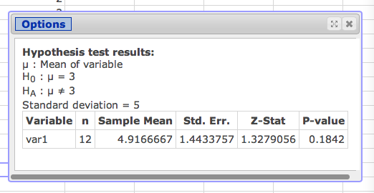

STEPS:

Step 2: n, sample mean (M), std error (om)

Step 4: Z-stat

Click options.

Click edit. Go back and switch it to confidence interval for u. If you want p<.01, change .99.

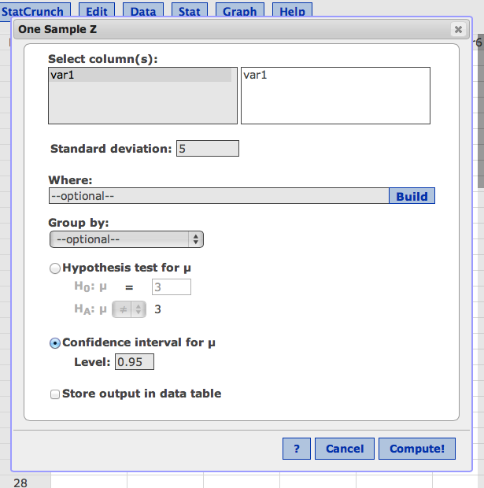

Hit compute.

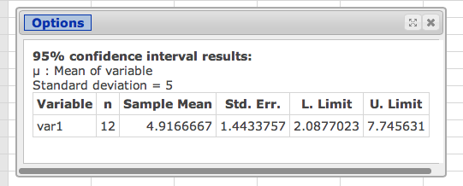

This will have the CI (l. limit and u. limit).

**One Sample Z-Test**

**With Summary**

Another option for single sample Z-test is when you know the characteristics of your sample distribution, such as Mean, Standard Deviation, and Sample Size.

For this option, Click “Stats” then select “Z-Statistics” “One Sample” and “With Summary”

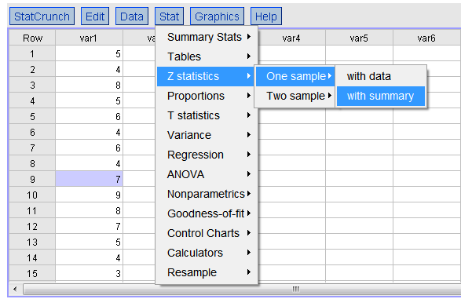

This will give you a window that will allow you to enter the characteristics of your sample distribution.

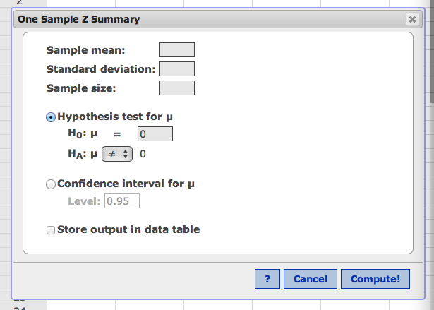

Enter sample mean (M).

Enter standard deviation (population, sigma).

Enter sample size N.

Enter population mean u.

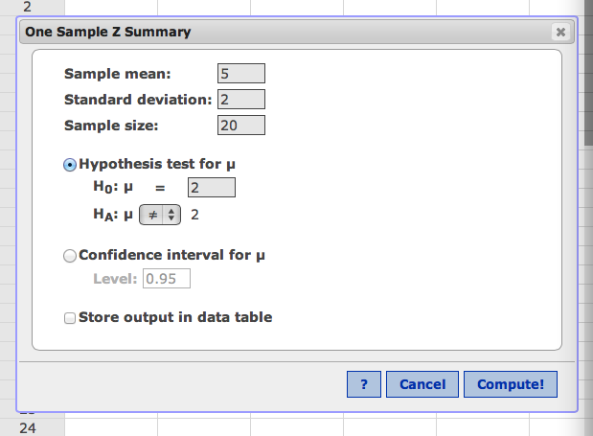

Hit compute!

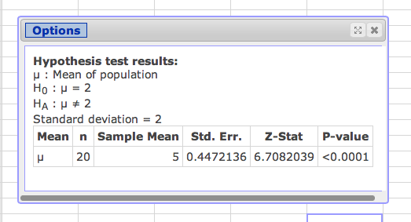

STEPS:

Step 2: n, sample mean (M), std error (om)

Step 4: Z-stat

Click options.

Click edit. Go back and switch it to confidence interval for u. If you want p<.01, change .99.

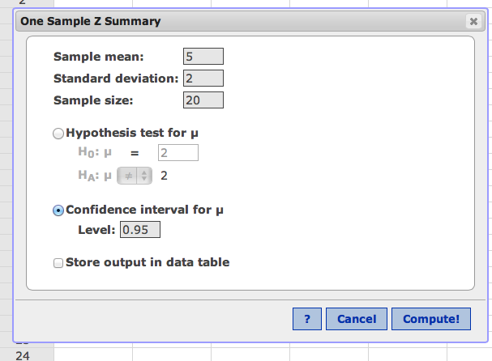

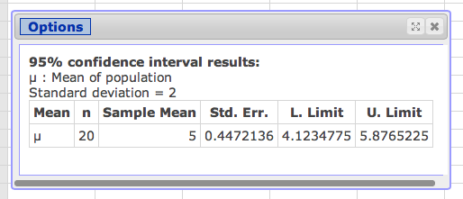

This will have the CI (l. limit and u. limit).